|  |  |  |  |  |  |  |
| --- | --- | --- | --- | --- | --- | --- |
| **Material** | **Methods of Preparation** | **Mass Fraction** | **Carbohydrate (wt% monomer basis) Glucan** | **Glucan % SSF residuals** | **Xylan % SSF**  **Residuals** | **Lignin**  **(K-lignin)**  **% SSF residuals** |
| Corn stover (from Dartmouth)  Solids reacted: 368.04 g | Dilute acid pretreated corn stover  (160 °C, 20 minutes)  Solids recovered: 176.02 g | 74.75% lignin from raw corn stover | 72. 34% Glucan  13.51% xylan | 60.2% | 6.3% | 26.1% |
| Dilute Acid pretreated Corn stover  Solids fermented: 176.02 g | SSF on DAP CS  Residual fermentation solids:  94.15 g | 78.73 % | 7.74% glucan  7.34% lignin | 12.05% | 6.40 | 51.40% |

* Solids presented in the table are on a dry basis.

Specifically, mass fraction (ie. how much HLFB from how much initial corn stover), carbohydrate %, lignin %, and microbial biomass

* Unfortunately, I did not measure the microbial biomass.
* **For the Where prepared, by whom?  I am looking for a paragraph suitable for a methods section in a publication.**

Six dilute acid pretreatments were carried out on the provided corn stover.

5 reactions were carried out at 7.5 wt% solids loading and 1 reaction at 5 wt% solids loading on an 800 gram basis. Untreated corn stover at the desired loading was soaked in 0.5 wt% mass dilute sulfuric acid (72 wt% purity) overnight at 4 °C. Pretreatment was carried out in a 1 L Hastelloy reactor (Parr Instrument Company, Moline, IL), equipped with an impeller, electric motor (Pacific Scientific Automation Technology group Radford, VA), thermocouple (Type K, Omega Engineering, Inc., Stamford CT), and a corrosion resistant pressure gauge (McMaster-Carr, Elmhurst IL). The reactor was heated by lowering the Parr reactor into a fluidized sand bath (Model SBL-2D Techne, Princeton, NJ) maintained at a set point of 320 °C. The heat-up of each reaction was measured by timing the reactions from 30°C to the desired reaction temperature of 160 °C. The temperature was maintained at the desired reaction temperature by raising and lowering the reactor at the surface of the sand bath and controlled to +/- 0.5 °C of the desired reaction temperature. The reaction contents were mixed at 180 rpm. Once the desired time of 20 minutes had been reached, the reaction was stopped by submerging the reactor to a room temperature water bath until the inside of the reactor reached 40 °C. The pretreated solids and liquor were separated by vacuum filtration. The pretreated solids were washed with 3.5 L DI water.

The pretreated solids were combined and the moisture content of 79.2% was measured using a halogen moisture analyzer (Mettler Toledo, Columbus OH). The composition of pretreated corn stover was measured using the established National Renewable Energy Laboratory (NREL) laboratory analytical procedure (version 08-03-2012). **The resulting composition of the pretreated biomass was measured to be 60.2 % glucan, 6.3% xylan, and 26.1% lignin.**

The pretreated solids were divided into 2 runs in a 3 L Bioreactor. The solids loading for each run was 83 g/L or 5 g/L glucan loadings. The enzyme Cellic® CTec2 was measured to have a protein content of 270 (mg/ml) by a BCA assay. The concentrated enzyme stock was diluted by 1/5 in MiliQ water for ease of transfer. The total volume of enzyme loaded was 13.9 mL or 15 mg/ g glucan loading.

* **For the "Were solids washed, organic growth factors or enzyme preparations added prior to fermentation?"**

The pretreated solids were added to the bioreactor Mili-Q water and autoclaved at 121°C for 30 minutes and cooled in the biosafety cabinet prior to the addition of the media. Pre-hydrolysis with all the media components and enzymes for 10.5 hours at 50°C when the bioreactor was cooled to 37 °C for the addition of *S. cerevisiae* D5A. After 12 total hours of pre-hydrolysis, the time 0 sample was taken and the bioreactor was inoculated at an OD600 of 2.1 for both bioreactor runs. The bioreactor was run at 37 °C at 130 RPM.

The bioreactor run was stopped after 10 days of fermentation. The free glucose was confirmed to be consumed by analyzing the fermentation broth sample via HPLC. The bioreactor contents were distributed into 4 1L centrifuged tubes and centrifuged at 12,000 for 20 minutes and separated. The broth was separated from the residual fermentation solids from each tube. The residual solids were collected and weighed and immediately stored at -20°C until shipped to Dartmouth.

* **Please specify the growth medium (all components), enzyme source and loading, and whether the solids were washed after they were harvested.**

Glycerol stock of *S. cerevisiae* (D5A) were grown in seed cultures overnight in an Erlenmyer baffled flask (Fisher Scientific, Hampton NH) containing 5 mL of filter sterilized 500 g/L glucose, 5 mL of autoclaved yeast extract and peptone (100 g/L and 200 g/L), 39 mL of autoclaved deionized (DI) water and 1 mL of the glycerol stock. After 10 hours, the seed culture OD was monitored to reach exponential phase. 50 mL of inoculum (5 % v/v) was added to the bioreactor after 12 hours of prehydrolysis.

Each bioreactor run had a working volume of 1000 mL. The bioreactor contained 398.86 grams of wet dilute acid pretreated solids, 100 mL of 10X concentrated YEP (Becton, Dickinson and Company, Redlands CA), 50 mL of Sodium Citrate buffer (pH 4.8) 10 mL of the antibiotic tetracycline (40 mg/L, Sigma Aldrich, St. Louis, MO), 377.25 mL of MiliQ grade water and 13.9 mL of Cellic® CTec2 (Novozymes North America Inc, Franklinton NC) equivalent to a 15 mg/ g glucan enzyme loading.

* **For the mass fraction remaining, it would be great if you could specify the dry weight of solids at the start (before pretreatment), after pretreatment but before SSF, and after SSF.**

|  |  |  |  |  |  |
| --- | --- | --- | --- | --- | --- |
| **Mass of Glucan, Xylan and K-lignin in grams after each processing step (dry basis)** | | | | | |
| Total (g) | **Raw CS** | **PT** | **SSF 1** | **SSF 2** | **Combined SSF** |
| **Dry solids** | 368.04 | 176.02 | 47.75 | 46.40 | 94.15 |
| **Glucan** | 146.48 | 105.96 | 5.97 | 6.11 | 11.34 |
| **Xylan** | 82.07 | 11.09 | 3.06 | 2.72 | 6.03 |
| **K-Lignin** | 61.46 | 45.94 | 23.87 | 24.54 | 48.39 |

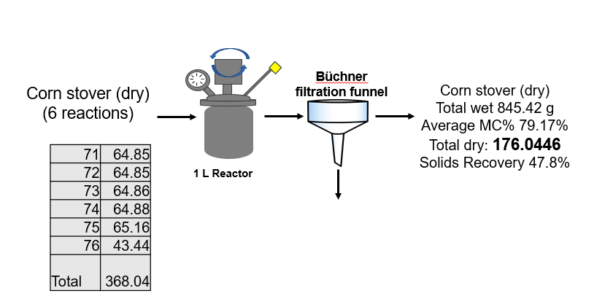

* **Finally, I think you mentioned that you were going to measure glucan and xylan in the final residual solids.**

The resulting SSF solids were dried and the composition was measured following the NREL procedure mentioned above. Below is the detail:

Glucan in the residual solids: 12.65%

Xylan in the residual solids: 6.05%

K-lignin in the residual solids: 50.70%